Farm Verse-Precision Agriculture Management Platform
Milestone 4
STATUS REPORT
Team c
1. Landing Page
Status: Completed
The FarmVerse landing page provides the initial interface for users visiting the application.
The landing page acts as the entry point of the application and allows users to understand the purpose of FarmVerse before accessing the system.
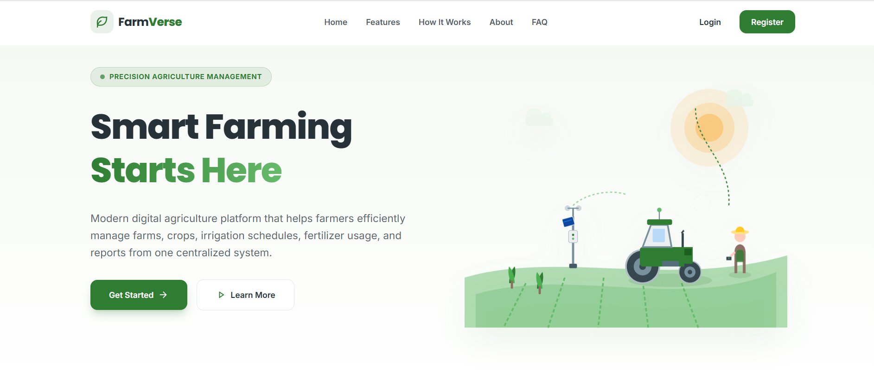
2. User Registration
Status: Completed
The registration module allows new users to create a FarmVerse account.
Registration Details
The user provides:
- Full Name
- Email
- Password
- Phone Number
Process
User
↓
Registration Form
↓
React Frontend
↓
Spring Boot API
↓
Validation
↓
MySQL users table
↓
Registration Successful
↓
Login Page
Database
User information is stored in the users table.
Result
After successful registration, the user receives a registration success message and is redirected to the login page.
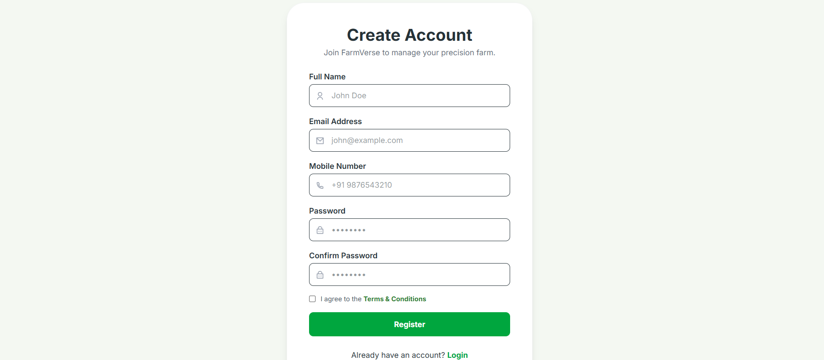
3. User Login
Status: Completed
The login module authenticates registered users before allowing access to protected application features.
Login Details
The user enters:
- Email
- Password
Process
User
↓
Login Form
↓
POST /api/auth/login
↓
Spring Boot
↓
Validate credentials
↓
Generate JWT
↓
Return token
↓
Frontend stores token
↓
Dashboard
Security
JWT authentication is used to maintain the user's authenticated session.
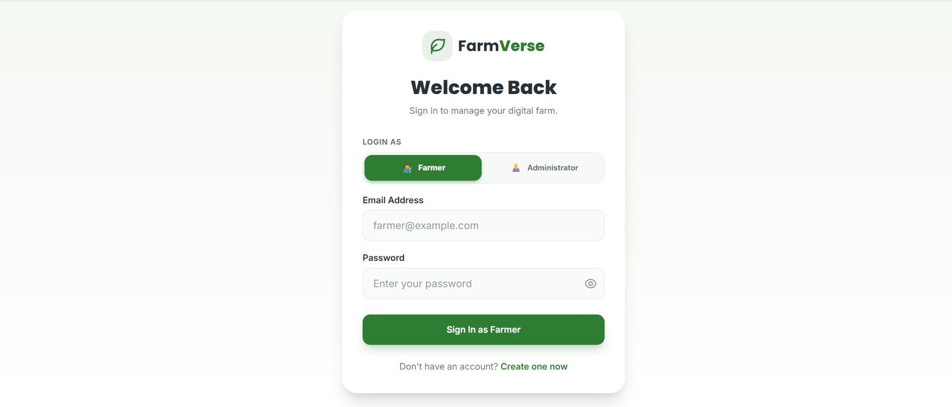
4. Role-Based Authentication
Status: Completed
FarmVerse supports two user roles:
- Farmer
- Admin
The role is stored in the database and associated with the user account.
Working
Login
↓
JWT
↓
Identify User
↓
Check Role
├── Farmer → Farmer Dashboard
│
└── Admin → Admin Dashboard
Purpose
Role-based authentication ensures that different users can access features according to their assigned responsibilities.
5. Dashboard
Status: Completed
The dashboard provides a centralized overview of the user's farm management activities.
Dashboard Information
The dashboard displays dynamic cards such as:
- Total Farms
- Total Crops
- Irrigation Information
- Fertilizer Information
- Other farm statistics
Dynamic Dashboard
The values are retrieved from the backend rather than being hardcoded.
For a newly registered farmer:
Total Farms 0
Total Crops 0
Irrigation 0
Fertilizers 0
After the farmer adds data, the dashboard automatically displays the updated values.
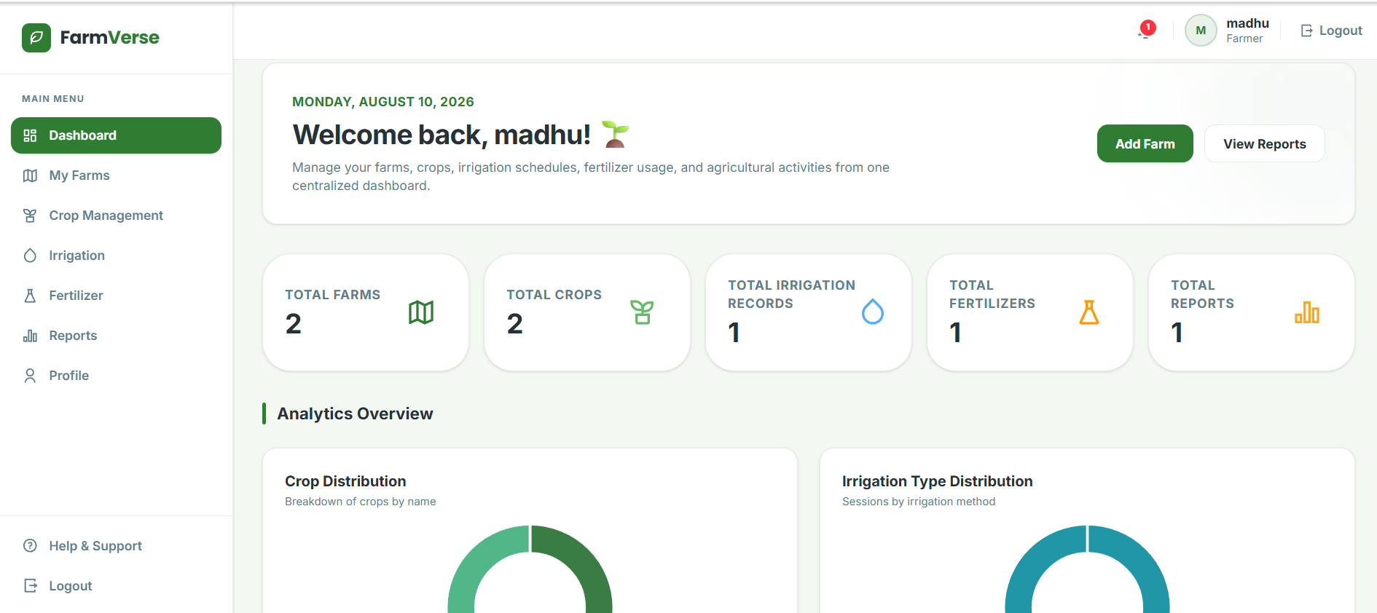
6. User Profile
Status: Completed
The profile module displays information belonging to the currently logged-in user.
Profile Information
- Full Name
- Email
- Phone Number
- Role
- Joined Date
- Account Status
Working
JWT Token
↓
Backend identifies logged-in user
↓
Fetch user information
↓
Return profile response
↓
React Profile Page
Security
The profile is retrieved using the authenticated user's identity, ensuring that one user cannot access another user's profile through the normal API.
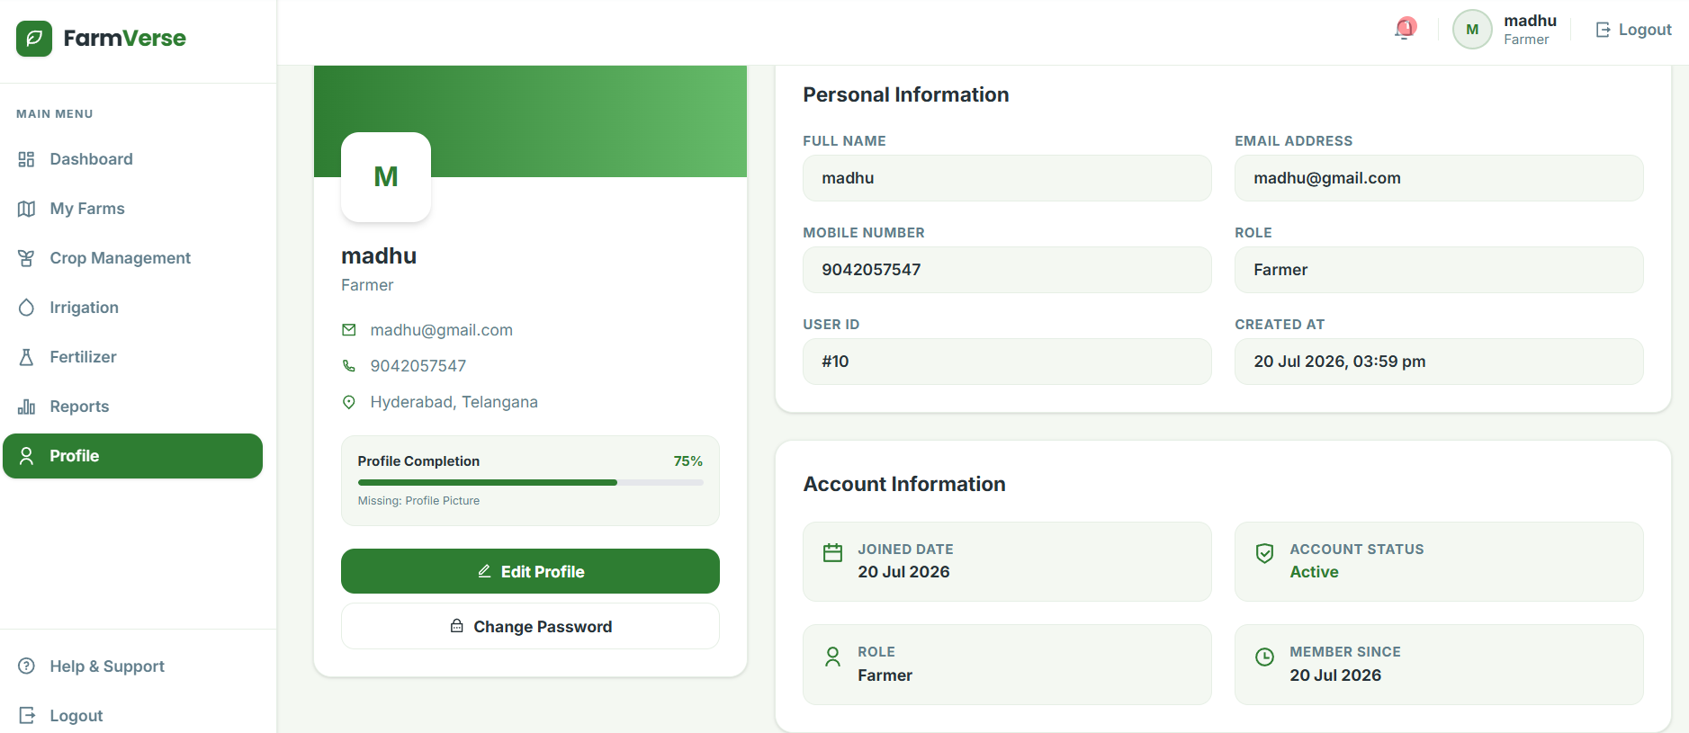
7. Farm Management
Status: Completed
Farm Management allows farmers to manage their farms.
CRUD Operations
The module supports:
- Create Farm
- Read Farm
- Update Farm
- Delete Farm
Farm Information
A farm can contain:
- Farm Name
- Location
- Area
- Soil Type
- Created Date
User-Specific Farm Management
Each farm is associated with a user through user_id.
Example:
User 1
├── Farm 1
└── Farm 2

User 2
└── Farm 3
Therefore, when User 1 logs in, only farms belonging to User 1 should be displayed.
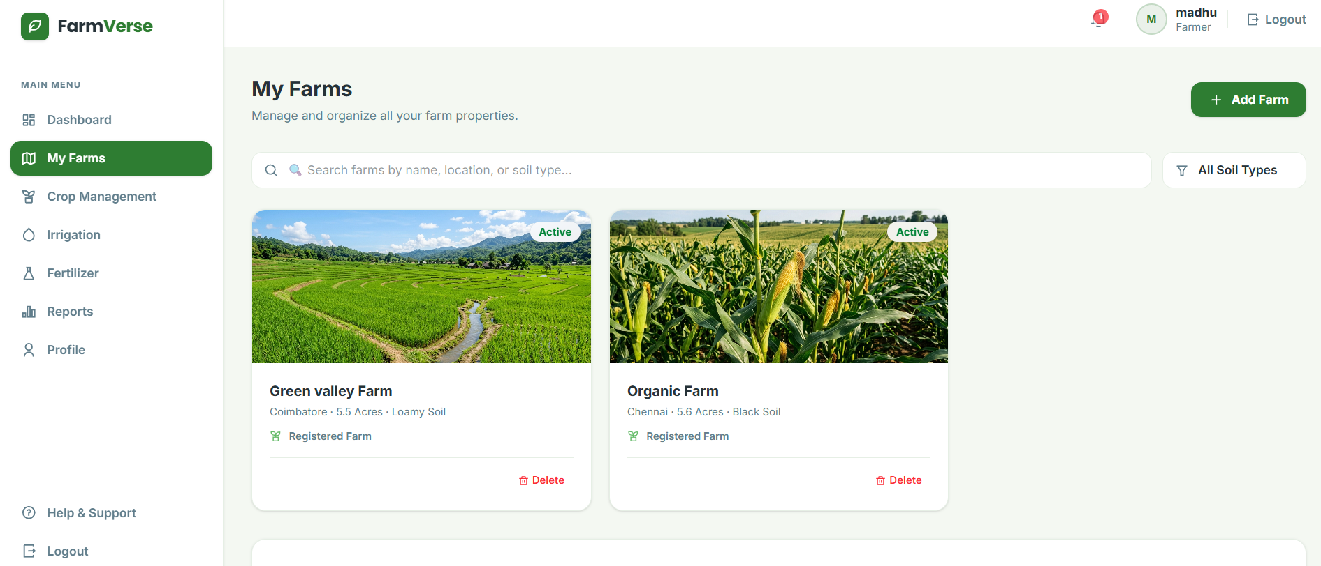
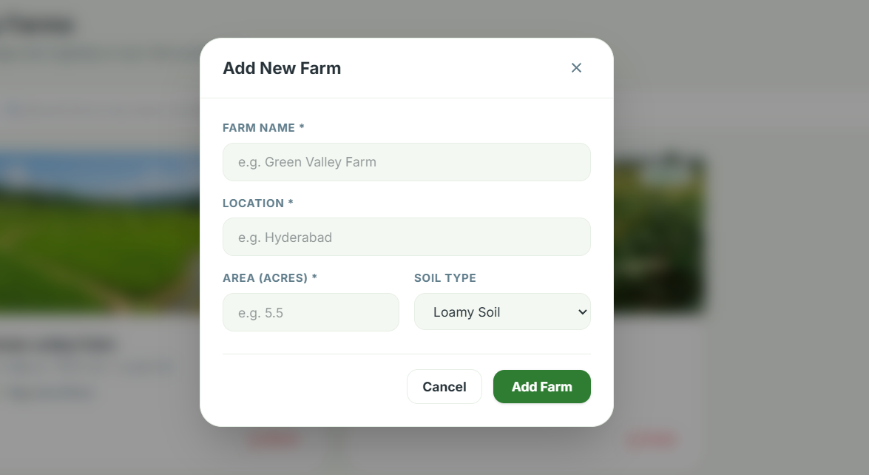
8. Crop Management
Status: Completed
Crop Management allows farmers to manage crops associated with their farms.
CRUD Operations
- Create Crop
- Read Crop
- Update Crop
- Delete Crop
Crop Information
- Crop Name
- Season
- Sowing Date
- Harvesting Date
- Status
- Farm
Relationship
User
↓
Farm
↓
Crop
Each crop is associated with a specific farm using farm_id.
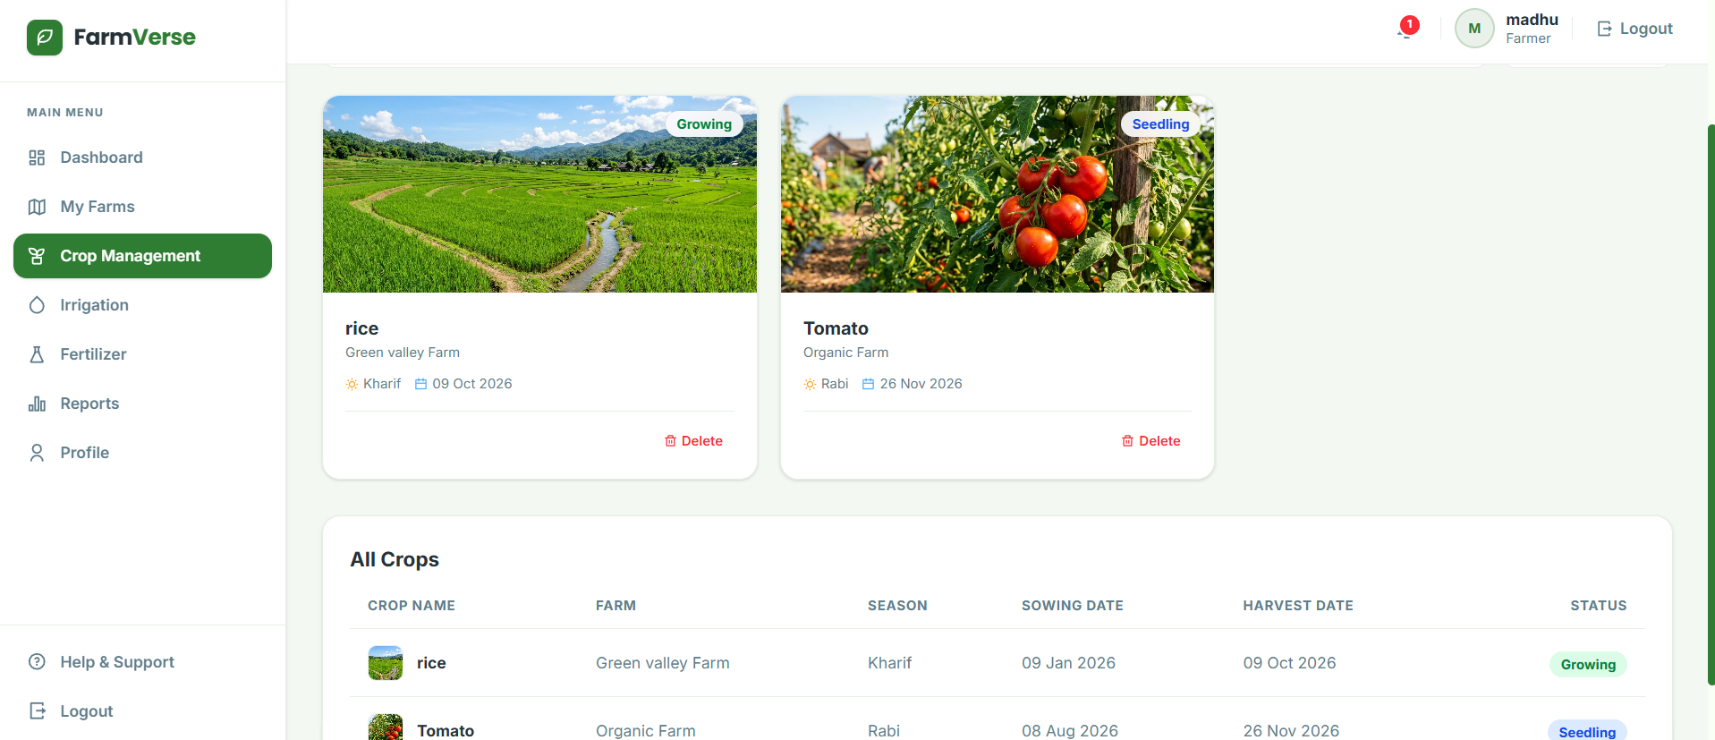
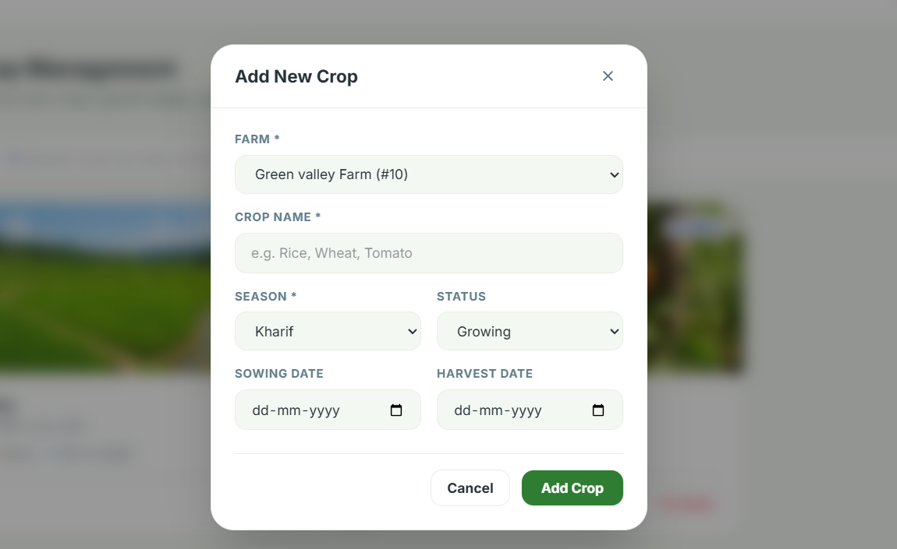
9. Irrigation Management
Status: Completed
The Irrigation Management module allows farmers to record and manage irrigation activities.
Information Stored
- Irrigation Type
- Schedule Date
- Water Quantity
- Remarks
- Farm
CRUD Operations
Create
Read
Update
Delete
Purpose
The module helps farmers maintain records of water usage and irrigation activities for individual farms.
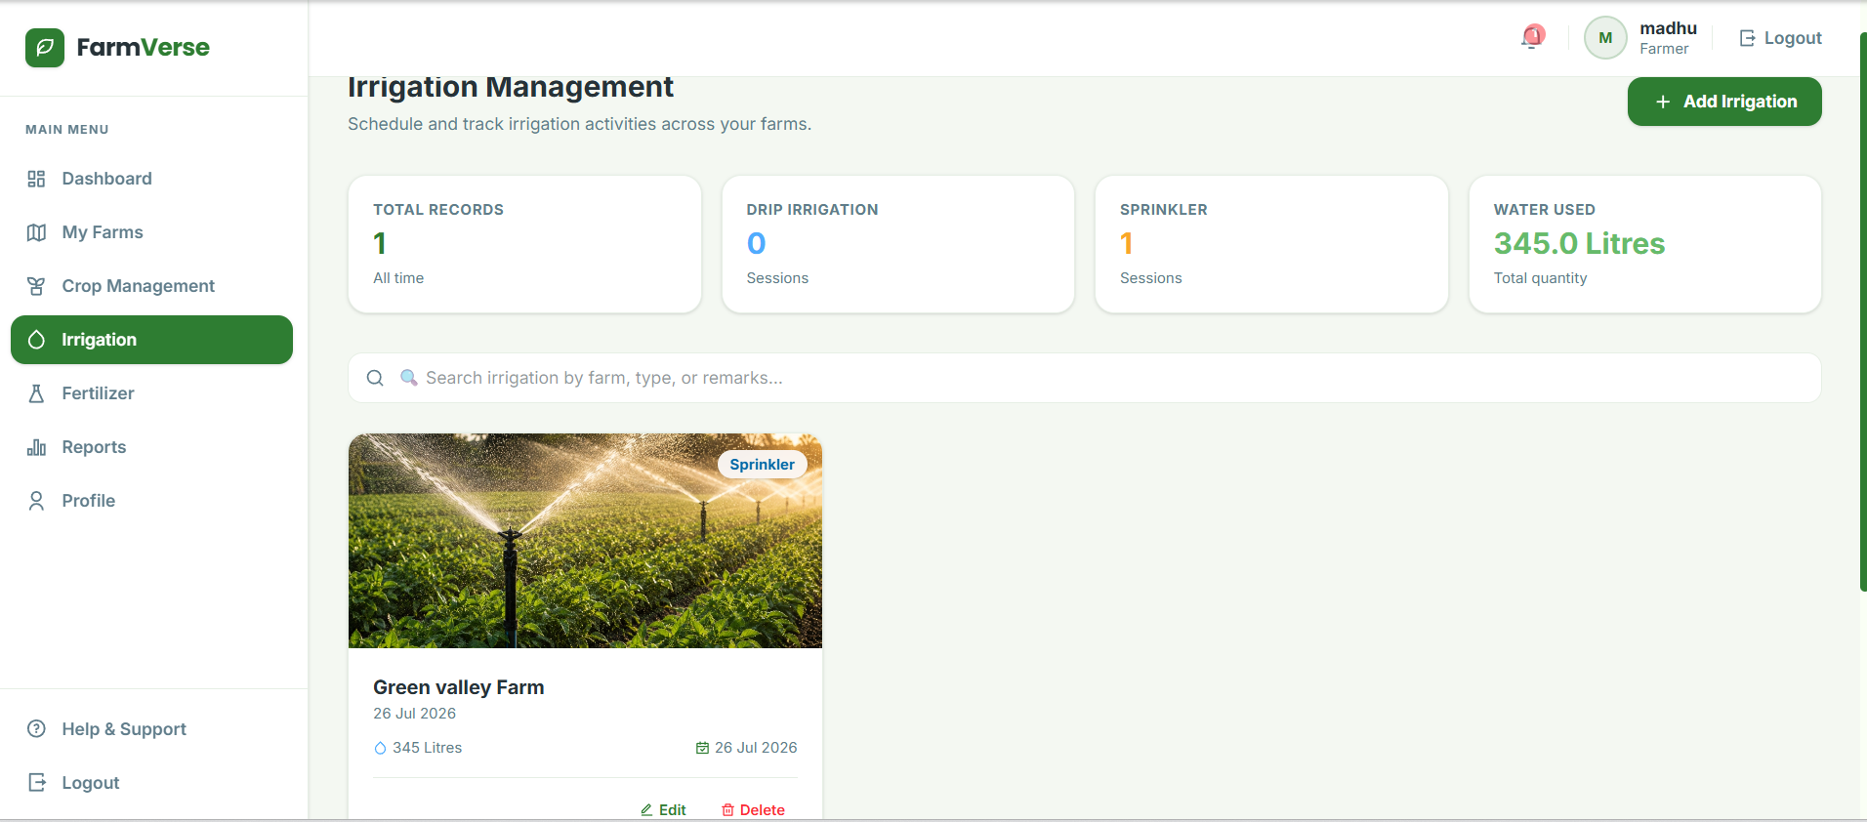
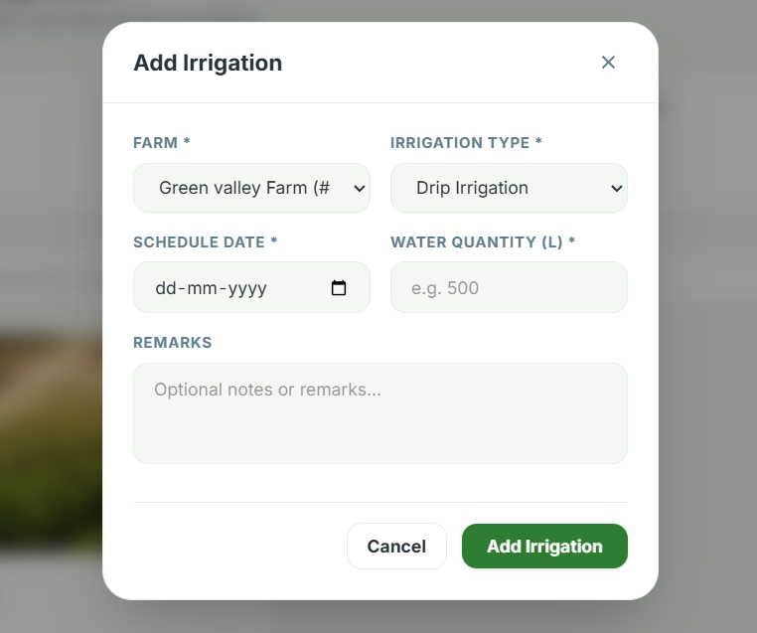
10. Fertilizer Management
Status: Completed
The Fertilizer Management module allows farmers to maintain fertilizer application records.
Information Stored
- Fertilizer Name
- Quantity
- Application Date
- Notes
- Farm
CRUD Operations
Create
Read
Update
Delete
Purpose
The module helps farmers monitor fertilizers used on their farms and maintain application records.
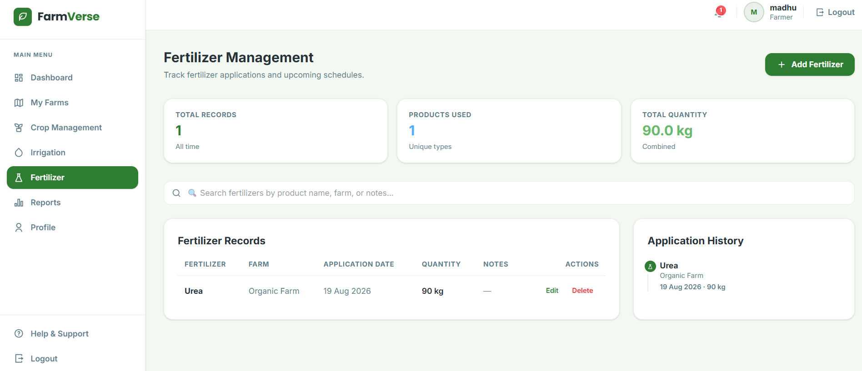
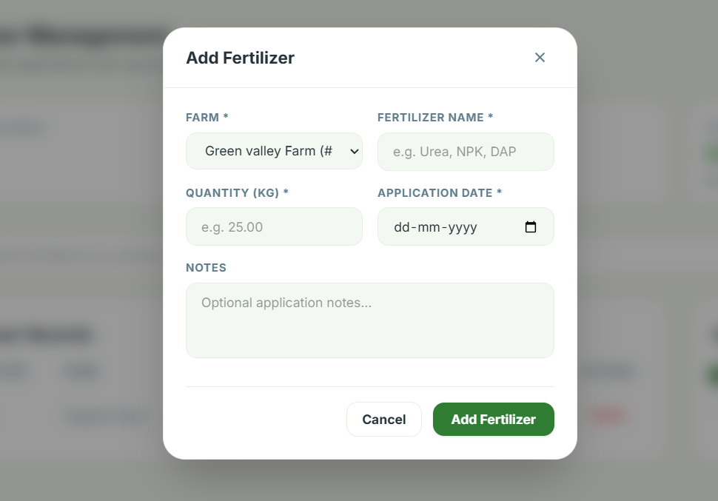
11. Report Generation
Status: Completed
FarmVerse includes a report generation module for maintaining farm-related reports.
Report Information
- Report Details – Report number, date, status, verification code.
- Farmer & Farm Details – Farmer name, farm name, location, land area, and soil type.
- Crop Information – Crop name, season, status, and harvest date.
- Irrigation Details – Irrigation type, water quantity, schedule date, and remarks.
- Fertilizer Details – Fertilizer name, quantity, application date, and notes.
- Agronomic Assessment – Overall summary of the farm, crop health, irrigation, and soil condition.
- Report Actions – View, download PDF, and print.
- Report Metadata – Generated date/time and FarmVerse verification information.
Purpose
Reports provide farmers and administrators with organized information about farm activities.
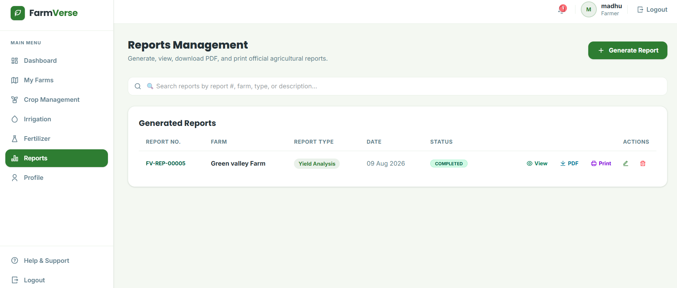
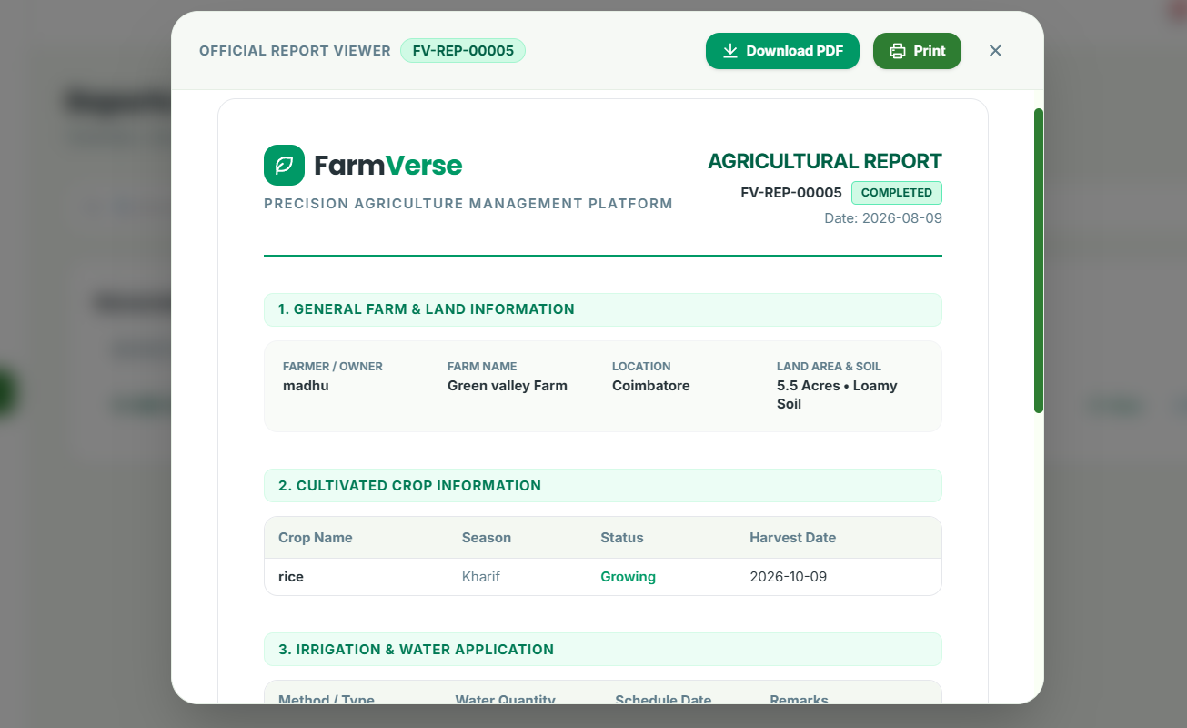

12. REST API Implementation
Status: Completed
The backend is implemented using Spring Boot REST APIs.
The major API modules include:
Authentication APIs
Profile APIs
Farm APIs
Crop APIs
Irrigation APIs
Fertilizer APIs
Report APIs
Dashboard APIs
API Architecture
React Frontend
↓
Axios
↓
REST Controller
↓
Service Layer
↓
Repository Layer
↓
MySQL
13. MySQL Database Integration
Status: Completed
MySQL is used as the primary database for FarmVerse.
Main Tables
users
farms
crops
irrigation
fertilizers
reports
Database Relationships
users
│
└── farms
│
├── crops
├── irrigation
├── fertilizers
└── reports
Foreign Key Relationships
farms.user_id references users.user_id.
crops.farm_id references farms.farm_id.
Other farm-related tables also use farm_id to associate records with the correct farm.
14. Frontend–Backend Integration
Status: Completed
The React frontend communicates with the Spring Boot backend through REST APIs.
Axios is used for HTTP requests.
Example Flow
React Component
↓
Axios GET/POST/PUT/DELETE
↓
Spring Boot REST API
↓
Service
↓
Repository
↓
MySQL
The response is then returned to React and displayed dynamically in the UI.
15. Postman API Testing
Status: Completed
Postman has been used to test backend APIs independently before integrating them with the frontend.
Tested Operations
- Registration
- Login
- Profile
- Farm CRUD
- Crop CRUD
- Irrigation CRUD
- Fertilizer CRUD
- Protected API authentication
Authentication Testing
Protected APIs are tested using:
Authorization
Bearer Token
This verifies that JWT authentication and authorization are functioning correctly.
16. Frontend UI Implementation
Status: Completed
The frontend provides a responsive user interface for farm management.
UI Components
- Landing Page
- Login Page
- Registration Page
- Dashboard
- Sidebar
- Topbar
- Profile
- Farm Management
- Crop Management
- Irrigation Management
- Fertilizer Management
- Reports
UI Features
- Responsive design
- Dynamic cards
- Forms
- Tables
- Navigation
- Icons
- Loading states
- Error handling
- Success messages
17. Backend Implementation
Status: Completed
The backend provides secure REST APIs and business logic for the FarmVerse farm management system.
Backend Components
- User Authentication & Authorization
- JWT Authentication
- Role-Based Access Control
- User Profile Management
- Farm Management
- Crop Management
- Irrigation Management
- Fertilizer Management
- Dashboard Data APIs
- Report Generation
- MySQL Database Integration
- CRUD Operations
- API Exception Handling
Backend Features
- RESTful APIs
- Secure JWT-based authentication
- Farmer and Admin role management
- User-specific farm data
- Create, Read, Update and Delete operations
- Database relationships using foreign keys
- Dynamic dashboard data
- Agricultural report generation
- PDF report generation
- Request validation
- Error and exception handling
- Appropriate HTTP status responses
- Postman API testing
- Frontend–backend API integration
FUTURE IMPLEMETATION:
AI Farming Assistant Chatbot
Answers questions related to crops, fertilizers, irrigation, pests, diseases, and farming practices using an AI model.
AI Crop Recommendation
Recommends suitable crops based on soil type, season, temperature, rainfall, and location.
AI Fertilizer Recommendation
Suggests appropriate fertilizers and application schedules using crop and soil information.
AI Irrigation Recommendation
Provides irrigation advice based on crop type, weather, and soil conditions.
AI Dashboard Insights
Generates intelligent summaries, alerts, and recommendations from farm and crop data.
AI Plant Disease Detection (Future Enhancement)
Allows users to upload crop images so AI can identify diseases and recommend treatments.
Benefits
- Provides personalized recommendations to farmers.
- Improves crop productivity and resource utilization.
- Supports faster and better decision-making.
- Reduces manual effort with AI assistance.
- Enhances the overall value of the application.

